SOP- Running Python Scripts for Image Processing and Analysis
Software
- Visual Studio Code
- Python
- Imaris with XTension folders configured (File ⇒ Preferences ⇒ CustomTools)
Procedure
- Open Visual Studio Code from the taskbar or Windows Start menu.

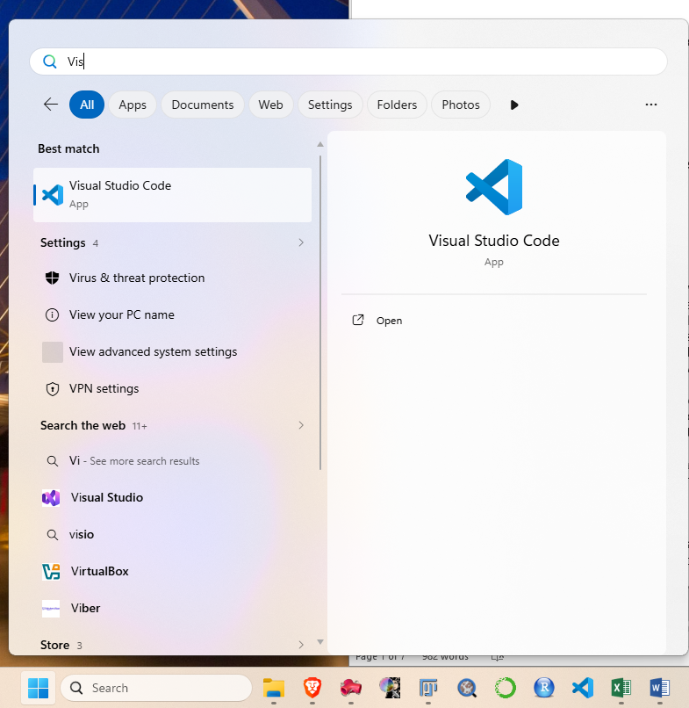

- Locating the Script
  - Use the “Explorer” tab (top left) to navigate through the file system. The “Python Scripts – OVERVIEW” document in the shared Drive details the functionality of all available Python scripts and lists their locations within the file system.
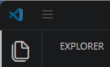
  - Click on the Python file you want to run. The file will open in a new tab within VS Code. You can now see all of the code contained within the file. 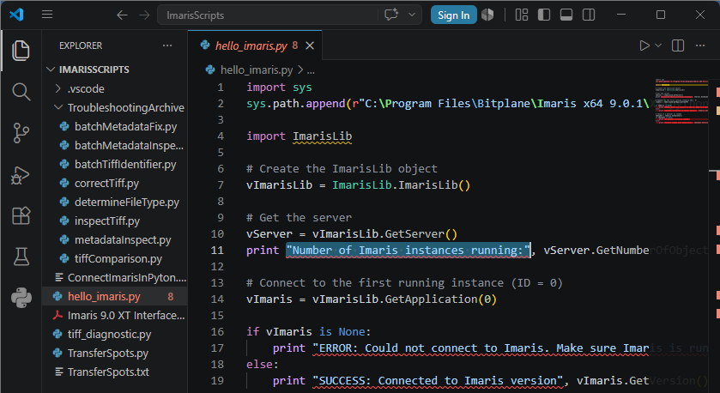
    - Note: All Python scripts should end in “.py” and show a blue plus sign beside the file name. If this is not the case, VS Code is likely not connected to a working Python interpreter and the code cannot be run.
  - Select the correct Python interpreter.
    - You should see the name of the selected Python interpreter in the bottom right corner. The correct interpreter for running Imaris XTensions is “imaris27”. This is an interpreter for Python v2.7, the version that is most compatable with Imaris v9.0.1.
    - If the Python script you are running is not an XTension, instead use the Python interpreter for Python 3.0, called “base (3.13.5)”.
    - To swap between interpreters, click the interpreter name to open a drop-down menu below the Quick Access search bar near the top of the screen.
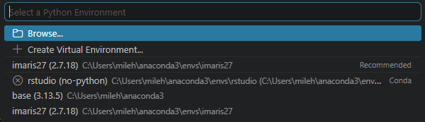

- Running the Script
  - Click the down arrow beside the play button (top right) to reveal a drop-down menu.
  - Select “Run Python File”.
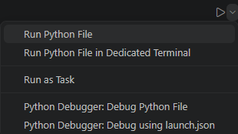
  - Check the Terminal window (bottom right) for details, instructions, and error messages.
    - Note: For Imaris XTensions to run, Imaris must be open on the computer you are running the XTension from. If this is not the case, you will see an error message.
